**RKA Mission Control Center**

From Wikipedia, the free encyclopedia

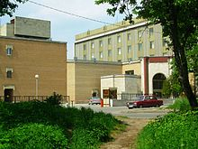

TsUP building

The **RKA Mission Control Center** (Russian: Центр управления полётами), also known by its acronym ЦУП (**TsUP**) is the mission control center of the Russian Federal Space Agency. It is located in Korolyov, in Bogomolov Street near the RKK Energia plant.

It contains an active control room for the International Space Station. It also houses a memorial control room for the Mir space station where the last few orbits of Mir before it burned up in the atmosphere are shown on the display screens.

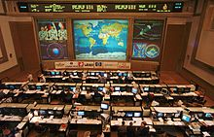

The main ISS mission control room

TsUP provides practical flight control for spacecraft of several different classes: manned orbital complexes, spaceships, space probes and civilian and scientific satellites. At the same time it carries out scientific and engineering research and development of methods,

Retrieved from "[http://en.wikipedia.org/w/index.php?title=RKA_Mission_Control_Center&oldid=513318639](https://en.wikipedia.org/w/index.php?title=RKA_Mission_Control_Center&oldid=513318639)"

This page was last modified on 18 September 2012 at 05:09.